

May 2019

Business Directory
Check out the Cover!
The business cards depicted on the glossy cover of our magazine are paid for by those who support our club – Please support those who support you.
In this issue...  - 2019 Calendar  - President’s report  - Secretary’s report  - Club Points Score:  - Chas’s Tech Talk  - Round two Phillip Island Report |  | 2019 Committee  PRESIDENT:  Gale Smith  M 0417 373 165  galeesmith@hotmail.com  SECRETARY:  Anne Gilliland  M 0408 320 199  info@assavic.com.au  TREASURER/MEMBERSHIP:  Stephen Craig  M 0407 992 390  Ss51@netspace.net.au  GENERAL COMMITTEE:  Michael Robinson  M 0418 505 635  michael@bellrealestate.com.au  Graeme Hume  M 0438 366 916  Gjhume1@bigpond.com  State Council Delegate;  Colin Smith - Mob: 0418 348 374  e: crges@bigpond.com
*The views expressed in articles included in these newsletters are not necessarily those of ASSA Vic
Postal Address; ASSA Inc., P.O. BOX 1306, NARRE WARREN 3805
Email Address; info@assavic.com.au

2019 Calendar

(While we have made every effort to ensure these dates are accurate, changes do occur, so keep this in mind when planning your program for 2019)

June 15th-16th Round 3
WINTON
June 26th Wednesday night Kelly Brothers workshop visit
July 19th-21st ASSA Vic promoter round
SANDOWN
Sept 28th-29th Round 4
PHILLIP ISLAND
Oct 26th-27th Round 5
SANDOWN Historics
Nov 23rd-24th Round 6
PHILLIP ISLAND 50K Plate
- This Newsletter may come to YOU accompanied by a MEMBERSHIP FORM. This probably means you are not a current paid up member. Please support the club by filling out and paying your subs











President’s Report

Round 2 of the State Race Series has been run and won at a very cold Phillip Island. Congratulations to Dean Camm for winning all 3 races on the weekend but it was very close between the first three placegetters.

The Sandown Historic meeting is approaching and we would like to get an expression of interest from those who are going to compete. As this is a prestigious event we are going to have to put on a good show, not only for the spectators but also make QPL proud to be part of our association. We have the National cars possibly 10-12 joining us but do need at least another 15 to satisfy VHHR and get an invitation to come back in 2 years time.

Our next project is the up and coming Round 4 of the VSCRC which we organize and run. Most of you know that it does take a lot of commitment from the key organisers who need (especially on Friday for the private practice) the help from all members. To help save hair loss and greying it would be great if people could start and put their hand up now of their availability. We are expecting a couple of big fields this year Formula Vee, Group N & Excels so Graeme is going to need help with his Grid Team on Saturday & Sunday. This is our biggest income for the year which helps to keep membership fees down and supports other functions throughout the year.

We have had the Sports Sedan site updated and are looking at increasing information on it so hopefully attract more interest in our class.

Thanks to Chris Neal for reminding us that we are 50 years old next August (some of us wish) and yes we are planning on doing something special for that, more information to follow.
Cheers
Gale
__________________________________________________________________
*Competitors please note, enclosed with your copy of this newsletter you will find a DRIVER PROFILE form. Please take the time to fill out the details and return to us as this is a way to increase your media profile and assist with race commentary

SDPICS
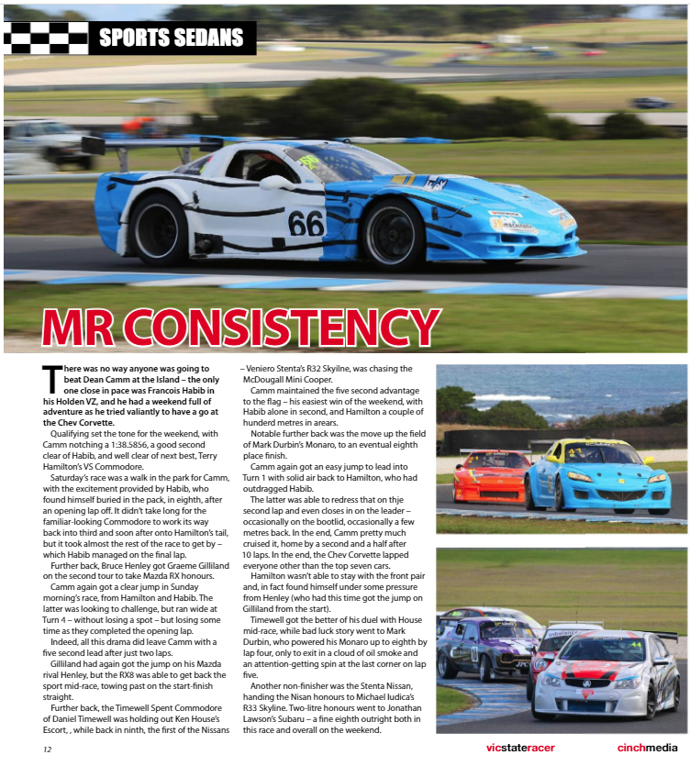
VIC STATE CHAMPIONSHIP RESULTS:
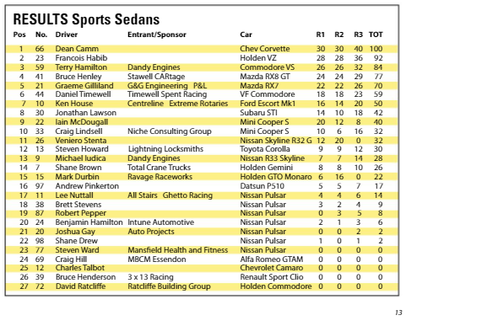

Vic State Race Points score

SECRETARY’S REPORT

Round 2 of the QP Lubes Victorian Sports Championship has just been held at Phillip Island. There were 25 entries, this included 2L Club cars. There were many battles going on through the field and this made for interesting racing. Whilst Dean Camm, Francois Habib and Terry Hamilton were at the pointy end, Dean didn’t seem to have any trouble to maintain a good lead and take the win in all three races. Well done to Dean, Francois and Terry for taking podium positions in all three races.
These first three were then followed by Bruce Henley and Graeme Gilliland, then a fair gap to the others in the field. It appeared at the beginning of the weekend there were a few problems with some of the slower cars but as the weekend went on this seemed to get better. Congratulations to the winners for the round.

Entries for Round 3, 15th & 16th June at Winton are now open. We sure need more cars on the track
particularly for this round. If you have a car in the shed, best you go and get it ready and come have a play at Winton. If you don’t have an entry and would like to enter – please contact me ASAP as the entries for this round are NOT through the on-line CAMS system.

Don’t forget that the next important thing to think about is our ASSA (Hotdog) Round at Sandown. This is no different to a normal race meeting for ASSA Members where you would normally compete. Instead you will be an Official and help in the running of the meeting. There are many jobs that need to be done and we need your help to maintain the high standard we have for our round. Please let me know if you can help out in any way possible, email to annebyers1@bigpond.com or call on 0408320199 to express your intention.

For any of you who have heard of Nathan Pretty, ex Thunderdome/Bathurst winner, we are hoping to have Nathan along to a general meeting very soon to have a chat about his racing career. This will be very interesting as Nathan has had a pretty successful path during his years of racing a lot of different categories. Last year Nathan won the Ute’s at Bathurst after about a year out. Keep posted for a date when we can arrange for this.
That’s about it from me at this stage.

Cheers
Anne Gilliland SDPICS
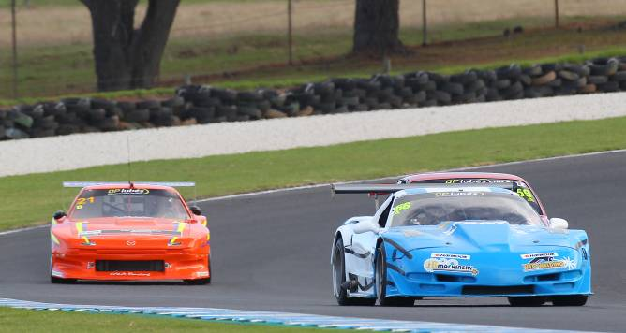
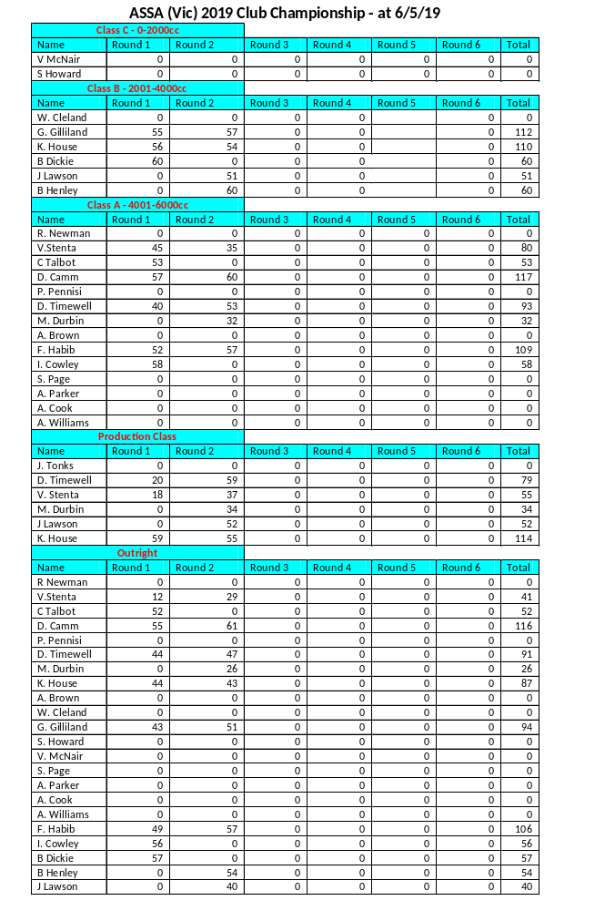

Round 2 Phillip Island: SDPICS
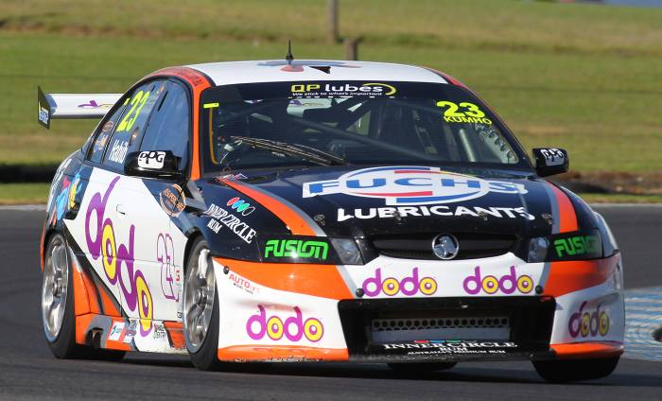
Great weekend for Francoise Habbib

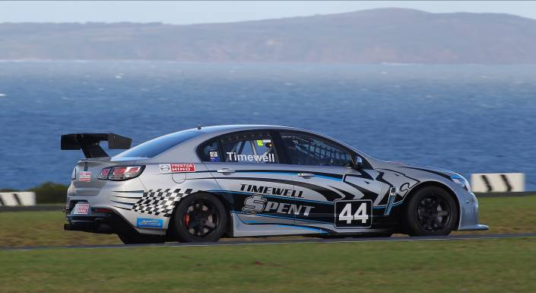
Danny Timewell put in a very consistent weekend

Chas’s Tech Talk

I would like to talk at length about some interesting details about muffling exhaust noise on a race engine. The obvious is to reduce the noise to an acceptable level without losing too much power. This noise problem is not such a problem when an engine is turbocharged, when the exhaust gases spin up the turbine some of the energy stored in the escaping exhaust gas pulse is lost in the process. In any case the exhaust noise is not the only disturbance but is perhaps the most important. The air intake also creates a pulsing of the air when entering the engine. The staccato bark of an open exhaust can carry a considerable distance, and is more prominent than the air intake. With multi cylinders using the same tail pipe the exhaust pulses following closely upon one another, seems to make the problem of taking off the “bark” easier. Another noise issue is the gears in the gear box, a racing gearbox uses “strait cut” gears, and this is done for strength and ease of manufacture, but is much noisier than “bevel cut” gears. Bevel gears are used in road cars for their quietness, but under high load are much more prone to failure.
The principle underlying the action of muffling is fairly simple. At the moment of opening of the exhaust valve the pressure conditions are such that the gases issue at velocities of approximately 2,000 ft. per second. The problem then becomes to reduce this velocity below that of sound (1,100 ft. per second) without causing undue back pressure. The bark of the open exhaust is due to the issuing of the gasses at velocities higher than that of sound, and the main disturbance is suppressed as soon as the velocities are brought below 1,100 ft. per second. When the gasses leave the exhaust valve they are under pressure and expanding and are hot, The further they travel the pulses begin to lose heat, reduce in size, and reduce their speed. Unfortunately on the relatively short length of exhaust as used on a race car, these will have little effect. We must then resort to placing a muffler of some design on the out let end of the exhaust system.

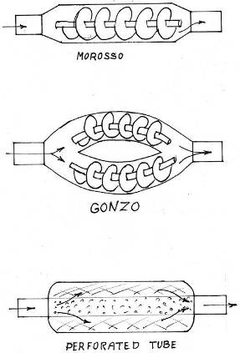

I did some back to back test on an engine dyno, with a 700 bhp engine and tried three types of mufflers commercially available. See attached drawings. (Apologies for the quality of the drawings) The Moroso and the Gonzo (the Gonzo, made in Qld and used on sprint cars). Both of these used a 20 mm tube with a spiral

similar to that used in a grain auger, wrapped around the tube. The idea being, by making the gasses spiral this would slow the speed of the gasses and reduce the incidence of the pulse. When a gas or water spirals along a tube it will travel faster than if it flows straight. The third muffler was a conventional straight through tube with perforated holes, allowing some of the pulse to escape through the holes into the packing surrounding the main tube. The standard to compare the mufflers to was a straight through pipe, of the same length and diameter. The Morroso muffler had the greater BHP loss at 35 BHP the noise suppression was good at low rpm, and increased at high rpm, but still within race limits. The Gonzo and the perforated tube muffler both lost the same BHP, that being 10 bhp. Which was surprising! With the Gonzo giving greater noise suppression. The orger like spirals is effective in smoothing and reducing the pulses. By using double the length of spirals in the Gonzo, this reduced considerably the resistance and back pressure as seen in the Morroso. So obviously Gonzo is onto something with his mufflers.
More next time
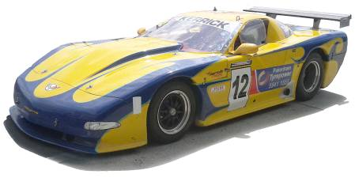
Chas
#12

The olde Vette....

Sandown Historics 2008 ....and it’s on again this year!
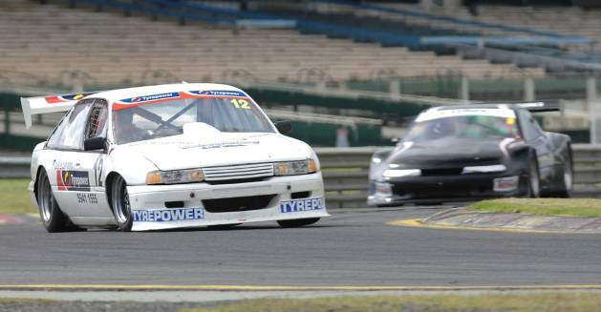

Round 2 Phillip Island: SDPICS
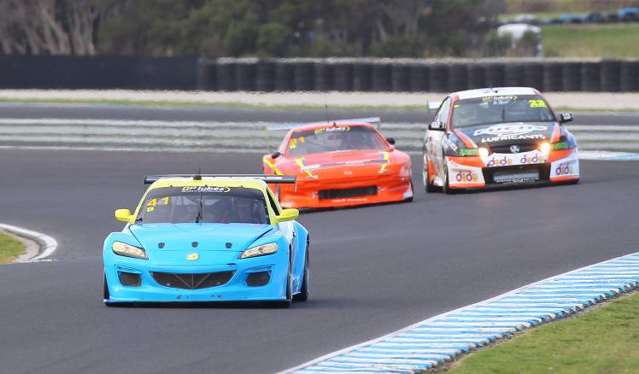
Some close racing here

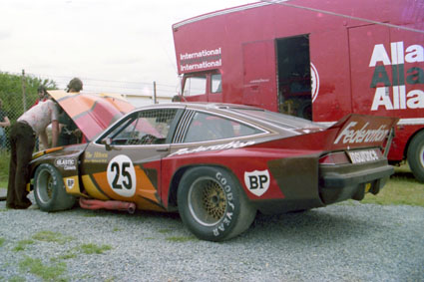

Sandown pits 1976. Such an awesome car!



WORKSHOP TOUR
WEDNESDAY 26TH JUNE

This should be a very informative night

Please note numbers are limited for this event.
We need to know if you wish to attend, so please contact
Anne Byers by phone, or email:
info@assavic.com.au
Book early!


_______________________________________________

Victorian Sports Sedan Driver Brett Dickie does Road Atlanta Georgia:


Back Page Nostalga
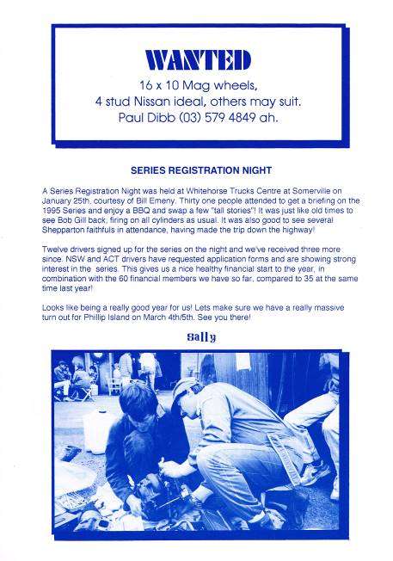

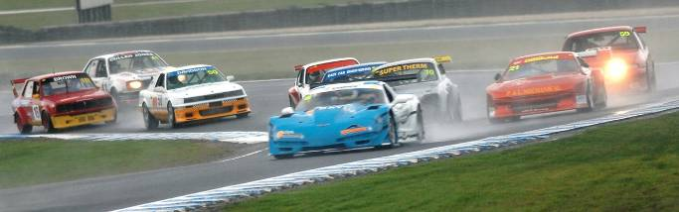
24 years back

Round one 10 years ago

